before commissioners appointed by
the maCKENZIE dISTRICT council

IN THE MATTER of a submission by The Wolds and Mt Gerald Stations regarding Plan Change 18 Indigenous Vegetation Clearance

EVIDENCE OF Dr PETER ROSS ESPIE
ON BEHALF OF THE WOLDS and MT GERALD STATIONS
12 February 2021

Duncan Cotterill
Solicitor acting: Katherine Forward
PO Box 5, Christchurch
Phone +64 3 379 2430
Fax +64 3 379 7097
Katherine.forward@duncancotterill.com

INTRODUCTION
- My full name is Peter Ross Espie. I am a research scientist who has specialised in the terrestrial ecology and management of the South Island high country tussock grasslands.
- I hold a B. Ag. Science degree (First Class Honours) from Lincoln College (1976) and was a University of Canterbury Senior Scholar. After post–graduate study at the University of British Columbia (Dip CS) I worked on forest soil ecology and completed a PhD in fescue tussock grassland ecology as a Hellaby Fellow at the Centre for Resource Management, University of Canterbury in 1987.
- I am a Director of AgScience Limited, an environmental consulting company.
- Prior to this I worked as a Technical Officer, Range Management, Department of Lands & Survey in the Canterbury High Country until 1978 when I undertook post -graduate studies (Dip. CS) and worked at the University of British Columbia, on soil/ plant ecology. From 1985-1992 I was a scientist at the Forest Research Institute, Christchurch and from 1992-2004 a scientist at AgResearch, Dunedin, working primarily on projects at Tara Hills High Country Research Station, and was an Honorary Research Fellow in the Department of Botany at the University of Otago.
- I was also a Director of The Queen Elizabeth the Second National Trust, evaluating conservation proposals for a wide range of ecosystems throughout New Zealand. I am currently the Chairman of the Balmoral Biodiversity Benchmark Trust, responsible for assessing, protecting, monitoring and ecologically restoring tussock grassland, shrubland and wetland systems in the Mackenzie basin.
- For 40 years I have actively researched the ecology of indigenous tussock grassland systems in the South Island and their management. I was the Field team leader of the Mackenzie Protected Natural Areas (PNA) Survey in 1983/4, responsible for designing and implementing a conservation assessment of the fauna and fauna in the Mackenzie Ecological Region (500,000 ha). I have subsequently been involved with a wide range of scientific botanical and ecological studies, and was the team leader of AgResearch’s High Country hawkweed Research Group.
- I have extensive experience with South Island tussock grasslands and have provided ecological and environmental assessments for district and regional councils and New Zealand and Australian government departments. I have been called as an expert witness for the Upper Waitaki Water Allocation hearings, Environment Court and Land Valuation tribunal hearings.
- I am familiar with the Mackenzie basin and The Wolds Station. Since the PNA survey in 1983/4, I initiated & have continued assessing the Mackenzie Basin Grazing Trial (1989 - present) investigating the effects of grazing on indigenous plant biodiversity in the major grasslands present the basin. I continued ecological research in the basin at Tara Hills High Country Research Station and surrounding properties (1992 - present). I have undertaken ecological assessments for 10 high country stations in the Mackenzie basin in relation to Tenure Review, which has involved extensive field survey (2005 - present). I have also co-supervised graduate students studies in tussock grassland ecology (PhD to Honours) and actively continue research in the Mackenzie basin.

SCOPE OF EVIDENCE
- I have been engaged by The Wolds and Mt Gerald Stations (Figure 1) to assess the effect of indigenous vegetation clearance proposals in the Mackenzie District Council Plan Change 18 on the biodiversity and terrestrial ecology of tussock grassland, shrubland and other ecosystems.

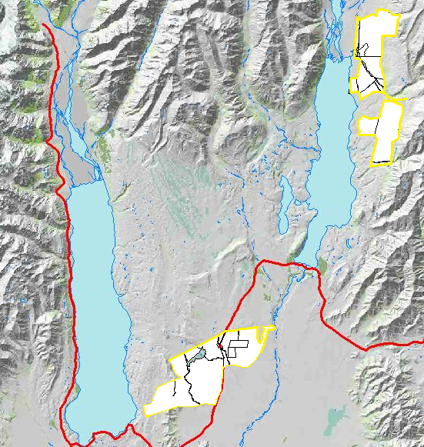
Figure 1: Mt Gerald and The Wolds shown in the wider context
- In preparing this evidence I have assessed the scientific evidence related to indigenous biodiversity provided by the Mackenzie District Council and make comments on the appropriateness of the proposed definitions and rules, based on my understanding of the science.
- My evidence is set out as follows:
  - Firstly, I have addressed the matters included in the evidence of Mr Mike Harding for the Council, including:
      - Ecological context;
      - Sites of Natural Significance;
      - Mapping provided by Council;
      - Wetlands
      - Contributors to Biodiversity Decline;
      - Offsetting;
      - Permitted vegetation clearance; and
      - Definitions
  - Secondly, my evidence sets out the science for my conclusions in relation to the above matters. This science is a culmination of a significant history of work in the Mackenzie Basin, and includes (most recently) site visits I undertook in February of 2021 to Mt Gerald Station, The Wolds Station, and several other long-term monitoring sites.

Ecological Context
- Mr Harding comments that the Mackenzie is the largest of New Zealand’s inter montane basins with extensive glacial and fluvio-glacial landforms and ecosystems which are not replicated to the same extent elsewhere in the country. The ecosystems and landforms that are present in the Mackenzie are also present in other eastern South Island inter-montane basins and are not unique.
- He notes that 91 threatened or data deficient indigenous vascular species occur in the basin, but they also occur in locations outside the Mackenzie. Only 20 species are Nationally Critical or Endangered. The conflation of ecosystem and individual species ecological value is a re-occurring error throughout his evidence, and is particularly apparent in his conclusions regarding various definitions, which I address further from paragraph 32 of this evidence. Effective threatened species management is different from ecosystem protection, and this is a distinction that Mr Harding has failed to make.
- Mr Harding considers that irrigation has recently reduced the extent of indigenous vegetation in the Mackenzie. This assessment is dependent on his definition of indigenous vegetation (with which I fundamentally disagree). He also does not mention that development frequently occurred on land designated as suitable for agricultural use under Tenure Review in conjunction with a large increase in land designated for conservation management, or as a condition of proceeding with irrigation development.
- When considering the context of PC18, I consider the history to the region is important, and I detail this from paragraph 55 of this evidence. To disregard the other processes that have controlled indigenous vegetation clearance and provided forms of protection is inappropriate, when determining which rules will manage land use on remaining farmland.

Sites of Natural Significance
- Mr Harding considers that identified Sites of Natural Significance are inadequate and incomplete and were not selected through a fit-for purpose comprehensive field survey. I disagree with his conclusion, as that was precisely the objective of the Protected Natural Area Survey of the entire Mackenzie Ecological Region. This survey identified, mapped and recommended the best examples of all indigenous ecosystems in the Mackenzie for protection. The Department of Conservation then included PNA Recommended Areas for Protection in detailed field assessment of conservation values in Tenure Review assessments in the Basin. The outcome of this process is extensive protection of all significant indigenous ecosystems in the basin.
- I agree with Mr Harding that there has subsequently been an increased focus on individual indigenous species since the PNA survey and note that this has been a key driver for achieving their full protection under Department of Conservation Tenure Review outcomes and conservation covenants. I am unaware of any threatened species or ecosystem that is not currently protected in the Mackenzie District.
- The scale of existing protection is shown in Figure 2 below, It is important to understand this scale, as I consider Mr Harding’s evidence downplays the areas already subject to controls. It is also important to understand that the areas already protected are the most significant (ecologically), which was the reason for their identification in the PNA survey and tenure review processes.

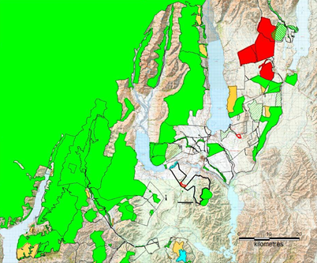
Figure 2: Crown conservation land (green), conservation covenants (tan), identified with botanical values in current tenure reviews (Green hatch) QEII covenants (blue) and private land that will not be developed (red).
- I consider that Mr Harding’s opinion that “Most undeveloped (un-converted) land on depositional landforms in the Mackenzie Basin has significant ecological values” is incorrect and is not supported by scientific evidence. I agree that some undeveloped land contains indigenous species or faunal habitats but consider that assignment of ecological significance requires actual assessment rather than a generalised value judgement. Large areas of what Mr Harding has identified as “undeveloped” or “unconverted” land is still subject to significant plant competition from exotic species, including browntop grasses and Hieracium. As outlined when addressing pest species and particular long term monitoring sites, I consider the greatest threat to indigenous biodiversity to be competition from exotic plant species.
- I do not agree that Outstanding Natural Landscape significance directly equates with ecological biodiversity significance or management. I note that this opinion was expressed by the Environment Court as part of the PC13 process, which was focused on landscape and was potentially missing relevant ecological evidence. I do not consider that it is appropriate to rely on these broad statements of the Court when presented with scientific evidence which establishes an alternative view.

Mapping Significant Natural Areas
- I agree with Mr Harding that ecological information obtained by field survey is superior to proxy estimation. However I consider that mapping ‘partially converted’ vegetation as ‘ … potentially significant indigenous vegetation’ from satellite imagery is subject to considerable difficulty in determining ecological significance and is, as he states, only a guide requiring further assessment.

Wetlands
- Wetland vegetation was mapped at a broad scale for the Mackenzie region by from PNA field survey. I agree with Mr Harding that the accuracy of the proxy Canterbury Wetland GIS layer is constrained by limited field survey.
- I have ‘ground truthed’ several of the locations shown on the Canterbury Maps Wetland GIS layer on my recent site visits to Mt Gerald and the Wolds. As shown in the images below, the GIS maps severely overstate the extent of the wetlands, in some cases areas shown as wetlands are dryland grass paddocks. These maps should be disregarded for the purposes of PC18, at least in relation to the two stations I have visited, as they are too broad to be helpful.

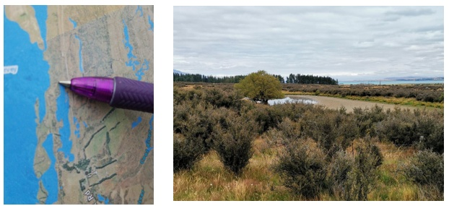
Figure 3: Wetland area on Mt Gerald Station. Location of the image on the right is shown by the point of the pen in the image on the left.

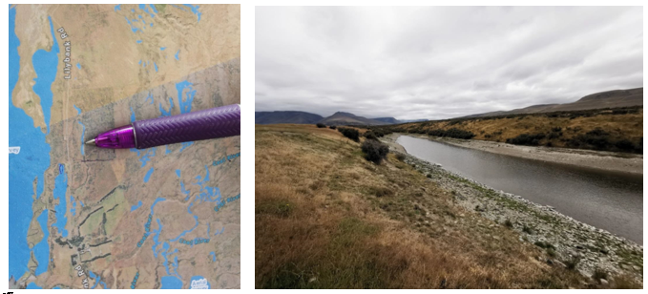Figure 3a: Wetland area on Mt Gerald Station. Location of the image on the right is shown by the point of the pen in the image on the left. Actual wetland is far smaller in extent and large areas of non-wetland, non-significant vegetation is including within the mapped area.

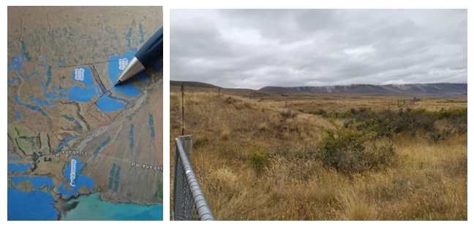Figure 4: Wetland area on Mt Gerald Station. Location of the image on the right is shown by the point of the pen in the image on the left. The actual vegetation at the location of the ‘wetland’ is not wetland at all, and consistent with dry grassland.
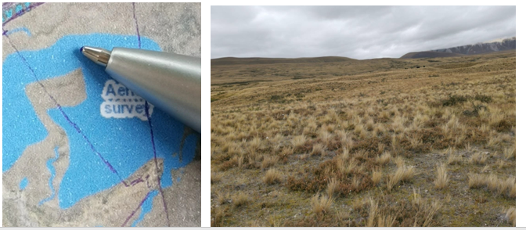 Figure 4b: Wetland area on Mt Gerald Station. Location of the image on the right is shown by the point of the pen in the image on the left. The actual vegetation at the location of the ‘wetland’ is not wetland at all, and consistent with dry grassland.

Contributors to Biodiversity Decline
- I agree with Mr Harding that factors other than land development contribute a decline in indigenous biodiversity in the Mackenzie District, however we appear to differ on our views of the source of most impact.
- I disagree that “the most common causes of vegetation loss are grazing, browsing (e.g. rabbits) or deliberate clearance”. I consider vegetation competition is the major factor in biodiversity loss, which is a secondary issue he later identifies.
- I agree that naturalised (exotic) plant species outcompete and smother most low-growing indigenous species and that rank growth of grasses is a significant threat. I am therefore puzzled by Mr Harding’s subsequent assessment that removal of grazing will effectively address biodiversity loss.
- My opinion that plant competition is the major function in biodiversity loss is supported by significant evidence I have obtained over four decades. This is set out in detail further on in my evidence, but in summary concludes that extensive grazing has no real impact on remaining grassland indigenous biodiversity. Instead, success of indigenous vegetation depends on the competition present from other, exotic, species.

Offsetting.
- I agree with Mr Harding that it would be very difficult to re-establish ecosystems given exotic plant and animal threats but fail to see how this will not also apply to recently formed land surfaces. I agree that plant succession could be managed to replace plant community/habitat but note that this will involve considerable expertise, input and expenditure.
- I do not consider that offsetting is appropriate or realistic in the Mackenzie Basin. As I will outline below, large areas of land have already been set aside for conservation and protection under various processes, but most particularly tenure review. Further, as Mr Harding and I agree, the likelihood of successful offsetting is low due to the exotic plant and animal threats.

Permitted Vegetation Clearance
- I agree with Mr Harding that vegetation clearance would generally exclude significant indigenous vegetation but note that this is dependent on what constitutes significant indigenous vegetation.
- As currently proposed, the permitted activity rules will authorise vegetation clearance in areas of “improved pasture”. I consider this to be appropriate, as where improved pasture exists, any indigenous biodiversity present will either:
  - Not be significant; and/or
  - has established that it is able to co-exist alongside the existing activity (for example over-sowing and topdressing) that has improved the pasture.
- A good example of the above is the presence of fescue tussocks in areas that have been oversown and topdressed historically. However, for the purposes of this permitted activity rule providing a pathway for continued use of improved pasture areas, it is critical that the definitions in the proposed Plan are precise and fit-for-purpose.

Definitions

Indigenous vegetation
- Mr Harding considers that definition of a 66% threshold of indigenous species cover proposed by Genesis and Meridian [and the Wolds and Mt Gerald Stations although these submitters are not mentioned] would not be ecologically appropriate. His rationale for this is that “ there are very few indigenous plant communities on depositional landforms where indigenous species form more than 66% cover” . He correctly notes that most basin floor plant communities are degraded and include a high component of exotic species and a substantial proportion of bare ground.
- He then proposes an inclusive definition of indigenous vegetation that would include vegetation at most remaining undeveloped areas in the Mackenzie Basin and in fact would encompass large tracts of land where exotic and native species co-exist. His justification for this is that “ … most undeveloped areas still support indigenous vegetation”. This confounds indigenous species and vegetation communities. While it is correct that such highly modified communities may retain an assemblage of indigenous species, to then define the whole community as indigenous on this basis is clearly fallacious. You could equally argue that an indigenous community that contains a few introduced species could be classified as exotic.
- I disagree that the presence and dominance of exotic species and bare ground is typical of indigenous vegetation in dryland areas of the Mackenzie basin. Rather, as I detail further on in evidence, it is a consequence of plant invasion and competitive exclusion. I simply do not understand Mr Harding’s next sentence. Why considering a definition of indigenous vegetation to: “… vegetation which included only a ‘minor element’ of exotic species” is inappropriate is puzzling. I consider that is exactly what is required. There is almost universal acceptance in ecological science that what constitutes a vegetation community is related to two primary attributes: species cover and abundance. There needs to be an acknowledgement within the definition that there are indigenous communities and exotic communities, and as a midway point there are communities which are a mixture of both.
- This is consistent with what I see in the field and is the reason for the relief sought by The Wolds and Mt Gerald in the original submissions made on PC18. The proposed changes sought in the submissions provide a simple, clear and practical classification of vegetation. A vegetation community where indigenous species comprises all the structural components of the vegetation (usually assessed as cover) and all the species in the community (usually assessed as abundance) is unarguably indigenous vegetation. Similarly, for introduced species, characterising introduced vegetation.
As set out in the submission, I consider the simplest and most useful classification is to define vegetation into three groups. This allows for a broader inclusion of either indigenous or introduced species within a specified vegetation class according to the following thresholds (Table 1, using percentage cover as a primary criterion of structural dominance). The range within the three vegetation classes is shown in Figure 5.  Vegetation | Indigenous species |  | Introduced species
Class | Lower | Upper | Lower | Upper
Indigenous | 66 | 100 | 0 | 33
Mixed | 33 | 66 | 33 | 66
Introduced | 0 | 33 | 66 | 100

Table 3. Vegetation class thresholds, percentage cover.

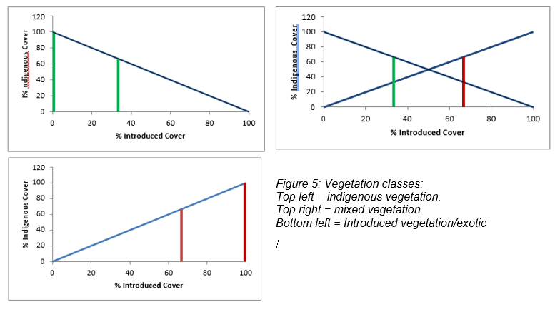
- Equally troubling is Mr Harding’s assertion that the definition of indigenous vegetation depends on an assessment of significance: “… that definition would exclude large areas of ecologically significant vegetation”. The assessment of significance is unrelated to definition of a vegetation community. It is possible to have a non-ecologically significant indigenous community.
- I suggest that Mr Harding’s proposed definition of indigenous vegetation be deleted, as it does not conform to accepted ecological standards, nor does it adequately provide clear and workable thresholds.

Vegetation Clearance
- Mr Harding considers that grazing has adverse effects on indigenous species but does not consider its possible beneficial role in conservation management. As outlined further on in my evidence, these adverse effects from grazing are overstated, and in fact grazing can positively control pest species such as wilding pines.
- I fully agree with Mr Harding regarding the risk of complete elimination of low-growing non-woody indigenous vegetation in the event of overplanting from taller species. The exception is exotic pasture grasses which can co-exist with low-growing non-woody indigenous vegetation
- Oversowing and topdressing does not always have an adverse effect on indigenous plant communities. It can beneficially increase the stature of indigenous dominants such as snow and fescue tussocks, and woody indigenous species such as matagouri, which can contribute to landscape value and, depending on application rate and frequency grazing regime, may allow persistence of indigenous species.

Improved Pasture
- I agree with Mr Harding’s (and submitter) concerns that a definition should be easily understood and applicable without expert ecological assistance. The answer is not to require that in an area of improved pasture all indigenous vegetation must be fully removed as proposed in Ms White’s report.
- Contrary to Mr Harding’s comment there are reliable baseline vegetation datasets available for many Mackenzie Basin areas. My field survey assessments are appended and identify years of data collection. I summarise the trends later in my evidence.
- I disagree with Mr Harding that it is hard for an ecologist to determine if exotic pasture species have been deliberately introduced. Two of the most widespread low-fertility pasture grasses present in the Mackenzie Basin were deliberately introduced by pioneering pastoralists and introduced pasture species are easily recognised. Changes since 1984 can be determined from the complete PNA vegetation mapping of the Mackenzie basin.
- I understand that the maps introduced as part of Mr Hardings evidence (which identify “converted” and “partially converted” land) are designed to assist in identifying areas of improved pasture. Firstly, I consider the misalignment of wording confusing – it would be beneficial for those maps simply to refer to “introduced pasture” overlays, for consistency with the definitions.
- As outlined above, the suggested definition of improved pasture is unduly restrictive “ ...where indigenous vegetation has been fully removed. .. ” as this would exclude introduced pasture containing indigenous species. Instead, I suggest the following revision of his definition:

“Means an area where vegetation has been converted to exotic pasture or crops.”
- Alternatively, I support the definition suggested in the submission of Mt Gerald and the Wolds as an improvement on the definition suggested by Mr Harding. I note that neither of the proposed definitions preclude evaluation of the ecological significance of such communities.
- I disagree with Mr Harding that: “ The ecologically appropriate time for the definition to apply is the date of satellite images” due, as he notes, that these are only draft maps, subject to confirmation and where mapping is not obvious or certain.
- As part of my site visit, I reviewed areas of land that had been identified as “partially converted” in these maps and consider them to be incorrect. Of those sites that I visited, the land was clearly “improved pasture” and was cut for hay and should be mapped as such. Unfortunately, the GIS maps were only made available to us the day prior to this evidence being due, and so I have been unable to view the maps in detail. I am happy to assist the Commissioners with my findings from the site visit against the maps at the hearing, if that is useful.

Scientific assessment of mackenzie terrestrial vegetation

- I used published information on landforms and soils as a framework for assessing terrestrial systems, as they strongly influence vegetation communities and fauna habitats (relationship shown in Table 4). Moraine, terrace and floodplain are the principal low altitude landforms.
Landform | Soil Association
Moraine, Old terraces & fans | Pukaki – Holbrook-Mary
Intermediate terraces & fans | Mackenzie - Fork
Young terraces & floodplains | Sawdon - Bendrose – Dobson
Table 4: Landforms and soil associations

- The Pukaki-Holbrook association occurs on moraines and old terraces associated with moraines. Pukaki soils are formed from deep fine sandy loess deposits and Holbrook and Mary soils are predominantly stony soils in wind deflation hollows.
- Mackenzie and Fork soils occur on intermediate-aged terraces and fans and encompass wide variation in stoniness and depth phases. Free draining shallow and deeper phases are determined by former stream channels.
- Sawdon-Bendrose-Dobson association soils are found adjacent to rivers and streams on young terraces and river floodplains. Complex inter-fingering of component soils occurs where younger alluvium has spread onto terrace surfaces or units are dissected by shallow stream channels. Free draining shallow and deep phases of Sawdon soils occur on the older flood plains and Bendrose soils on younger surfaces. Dobson soils occur in localized poorly drained areas of silt alluvium.

Mackenzie Basin Vegetation Change 1962 – 2021
- Vegetation change in the Mackenzie basin can be scientifically assessed from 1910 until the present. The Mackenzie Basin has some of the best long-term study sites available for assessing indigenous biodiversity. The botanical composition of tussock grassland communities was surveyed in the 1960’s and all communities in 1980’s. Subsequently detailed long–term monitoring has been in progress since the 1990’s at ten representative basin floor and mid-altitude sites. Other long-term sites are available from Grey’s Hills, Glenmore and Tara Hills High Country Research Station.
- In 1962 grassland and related associations in the Mackenzie Basin were assessed during a floristic assessment of Canterbury grasslands. Sample sites considered representative of communities were selected after general inspection of vegetation communities in the area. At each site vascular plant biodiversity was determined by recording the presence and visually scoring percentage cover abundance of all species present in 100 m2 plots.
- The Protected Natural Areas (PNA) Program in 1983/84 was comprehensive survey of the entire Mackenzie Ecological Region to identify conservation values requiring protection. Vegetation associations, fauna and geomorphology were directly examined by field survey, and subsequently classified into ecological units. Vegetation communities were described according to cover and composition of the most the most abundant plant species in representative sites. Cover and abundance of all species were also recorded in ~ 100 m2 plots representative of the ecological unit. Vegetation associations were mapped for the entire Mackenzie Basin. An example of this is shown in Figure 6, from Glenbrook Station. The same data is available for Mt Gerald and the Wolds.
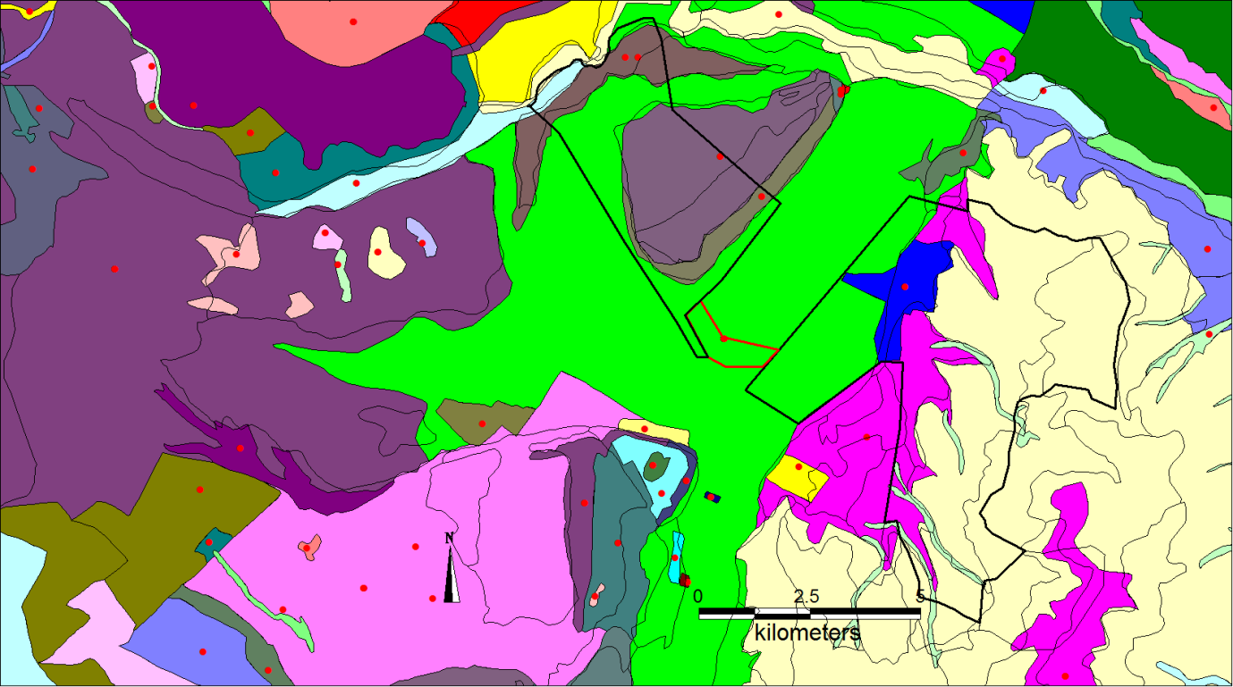
Figure 6: PNA survey plots and ecological units in 1984.
Coding: Ecological Units delineated by thin black lines, survey plots red dots; Glenbrook Station boundary by thick black lines.
Green: Fescue tussock grassland,
Purple: Fescue tussock grassland with shrubs,
Olive and pink: Fescue and introduced grasses;
Blue :Agricultural.
- To understand subsequent trends on the terrestrial biodiversity on The Wolds, Mt Gerald and other properties, a long-term experiment examining conservation management of tussock grasslands commenced in 1989. Four short tussock grassland sites on the central Mackenzie basin fluvioglacial outwash were selected, one on Ben Ohau station (4 km north east of Twizel), one on Simons Hill station, and one on Maryburn station and one at Sawdon Station, near Tekapo. At each site there were three grazing treatments. Two 75 x 75 m exclosure plots excluded rabbits and stock (nil grazing, coded –R-S), or stock but allowing rabbit grazing (+R-S). An equivalent area of adjacent grazed grassland was grazed by rabbits and stock (+R+S). All plant species present in eight quadrats in a 20 x 20 m plot were recorded in each treatment and their percentage cover scored.
- The current floristic and ground cover composition of vegetation communities on Simons Pass and Simons Hill was assessed by field survey in May, September and November 2008 and Maryburn in 2012. All the main vegetation associations and landforms were examined and the percentage ground cover was scored from randomly located sample quadrats in representative sites.
- The vegetation communities present on the proposed development area in The Wolds are categorised as fescue tussock (Festuca novae-zelandiae) short tussock grassland associations, or derived communities
- It is possible to compare results across the different vegetation assessment studies at different times as representative sites and communities were chosen for description, methods are comparable and the fluvioglacial outwash landform and soils are very uniform.
- The sites on the Pukaki outwash surface which provide the best sequence of vegetation change in the most extensive association on The Wolds, fescue tussock grasslands are Simons Hill and Ben Ohau. Detailed floristic investigations, which specifically aimed to record all species present, were made in the 1962 survey and the 1989-2008 grazing study. The 1984 PNA sites did not all record total species biodiversity, but were used for comparing recorded major ground cover components at all sites with detailed biodiversity assessment at representative sites.
- These sites occur on the similar landforms and soils that are present on The Wolds and Mt Gerald and were classified together by floristic analysis into the same short tussock grassland vegetation association in 1984 and experience a similar climate. These sites have been assessed more frequently than The Wolds and therefore I have used them to show more precisely the temporal trends in fescue tussock grasslands in the central Mackezie Basin. The trends are consistent with, and directly applicable to, those occurring on The Wolds.
- At both Ben Ohau and Simons Hill, there was a marked decline in fescue tussock cover accompanied by an increase in bare ground and Hieracium (Figures 7 and 8). The increase in bare ground (note this class does not include rocks, stones, surface dead or detached plant material) was greater at the drier Simons Pass site, but the total cover of bare ground and Hieracium was very similar at both sites (62% and 64% respectively).
- Full biodiversity data to 2021 is available for Mt Gerald/Richmond, Ben Ohau and Maryburn, and to 2015 for Simon’s Hill and Balmoral. Unfortunately due to time and length constraints I have been unable to include this data, however it confirms trends to the situations outlined above.

Figure 7. Long term changes in ground cover 1962-2008, Pukaki Flat, Simons Pass.
Fnz fescue tussock;
Hpil Hieracium pilosella
Figure 8. Long term changes in ground cover, Pukaki Flat, Ben Ohau station.
- The number of species occurring in both communities deceased after 1962
(Figures 9 and 10).

Figure 9. Long term changes in vegetation species number, Simons Pass Station, Pukaki Flat.

Figure 10. Long term changes in vegetation species number, Ben Ohau station, Pukaki Flat.
- These changes in species are consistent with the species occurring on The Wolds.
- Detailed examination of these trends at Simons Hill shows that differences in grazing had little effect on major ground cover changes (Figures 11 - 14). Similar trends occurred at Ben Ohau (not presented).

Figure 11. Changes in bare soil exposure, Pukaki Flat 1990 -2008.

Figure 12. Changes in fescue tussock cover, Pukaki Flat 1990 -2008.

Figure 13. Changes in Hieracium pilosella cover, Pukaki Flat 1990 -2008.

Figure 14. Changes in a typical herb cover, sheep’s sorrel, Pukaki Flat 1990 -2008.
- Fescue tussock density and size assessment support the vegetation cover assessments. Fescue tussock markedly decreased between 2000 and 2008 (Table 5).
Grazing | No. tussock groups |  | % Live tussock |  | Total live Basal Area (cm²)
 | 2000 | 2008 | 2000 | 2008 | 2000 | 2008
Rabbit & Sheep | 6.1 | 0.1 | 7.5 | 0.0 | 323.4 | 0.0
Rabbit | 0.8 | 0.0 | 1.0 | 0.0 | 22.4 | 0.0
Nil | 3.8 | 0.4 | 5.7 | 1.1 | 97.7 | 1.4
Average | 3.6 | 0.2 | 4.7 | 0.4 | 147.8 | 0.5
Table 5. Changes in fescue tussock density m⁻², % composition and size, 2000 – 2008.

- It is highly probable the decrease in fescue tussock was directly due to competition from Hieracium. The increase in bare ground and reduction in species occurrence is almost certainly a direct consequence of hawkweed patch growth, as has been established from ecological research elsewhere in the Mackenzie basin, .
- These changes affected extensive areas (Figures 15 - 16).
- The same invasion of Hieracium has occurred on The Wolds (Figures 17) and Mt Gerald.
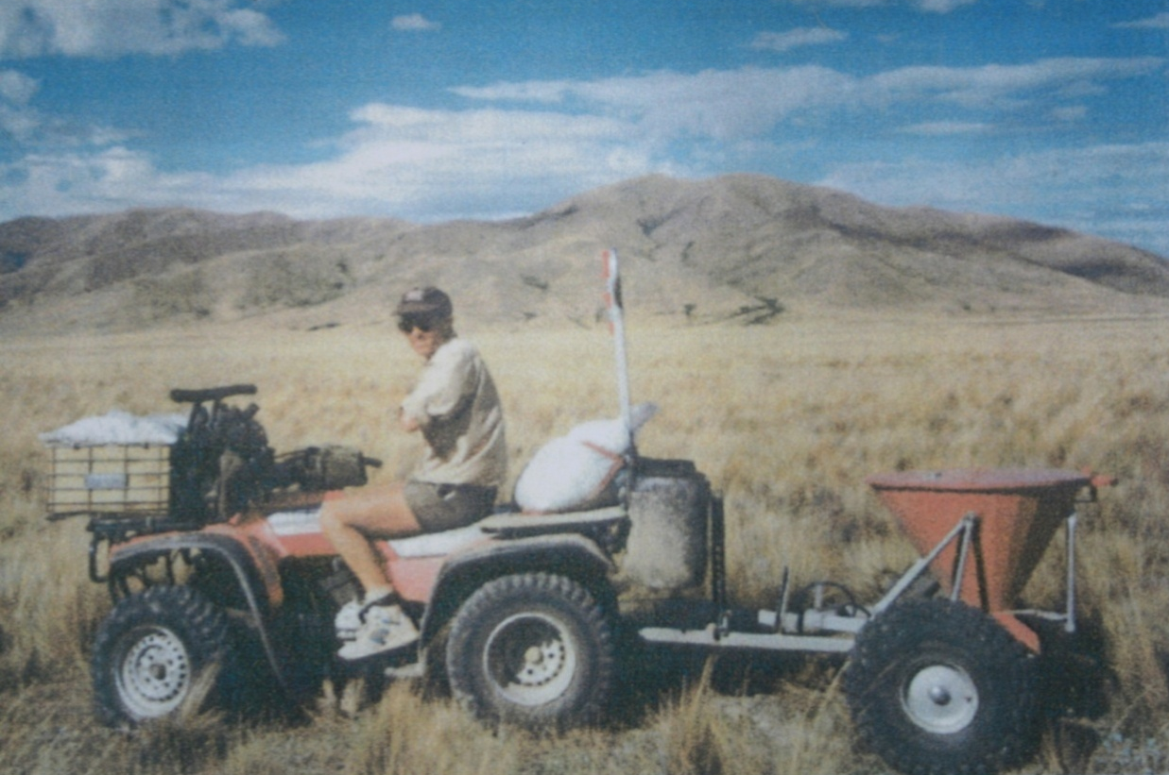
Figure 15. Simons Hill, Pukaki Flat in 1995, fescue tussock grassland, PNA Recommended Area for Protection.
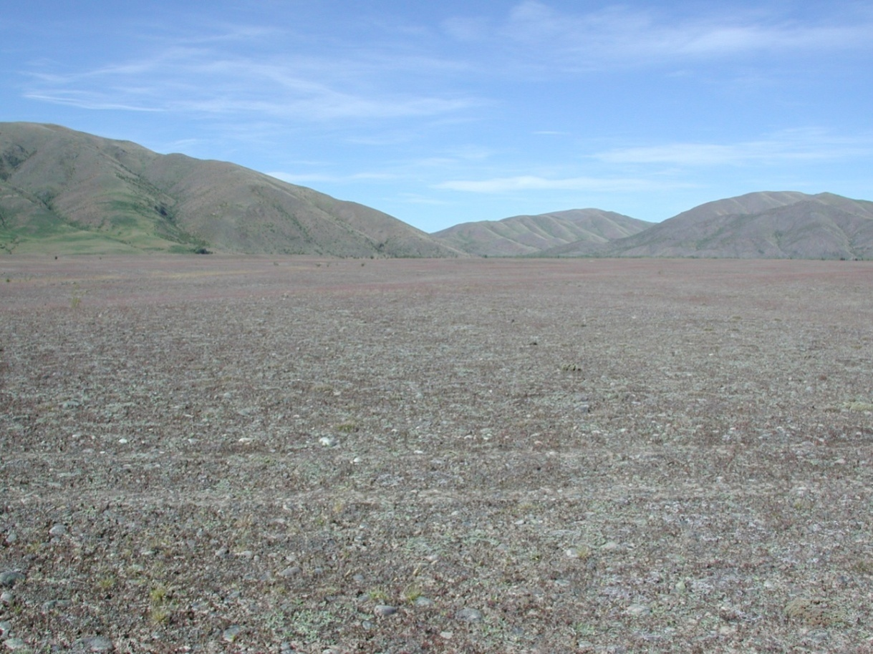
Figure 16. Simons Hill, Pukaki Flat in 2009, now Hieracium herbfield and bare ground.
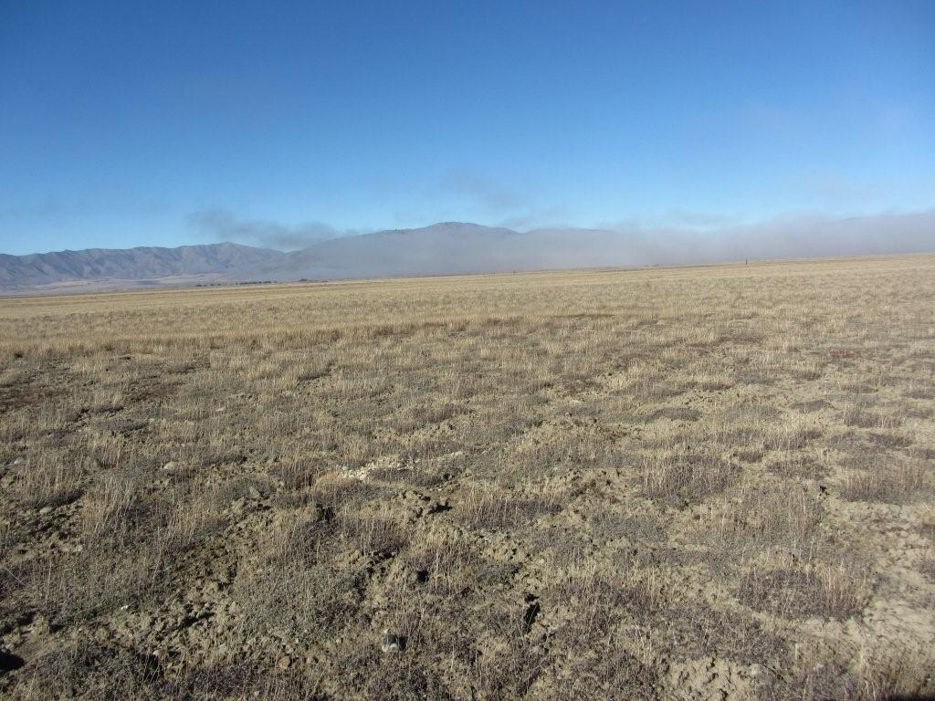
Figure 17. Former short tussock grassland, now Hieracium herbfield and bare ground. Simons Hill Pukaki Flat in May 2012.
- Maryburn Station is located 10 km from the Wolds on the same fluvioglacial outwash landform and had the same original short tussock vegetation in 1983.
- Similar to Ben Ohau and Simons Pass, Hieracium increased, as shown on Figure 18 below.
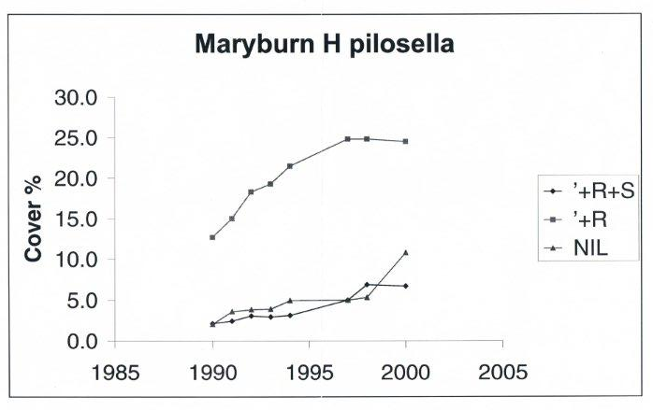
Figure 18. Changes in Hieracium cover Maryburn grazing trial 1990 – 2000.
Legend. +R+S grazed by rabbits and stock; + R grazed by rabbits; Nil no grazing.

- Sawdon Station is located 30 km North East of the Wolds on the same fluvioglacial outwash landform and had the same original short tussock vegetation in 1983. Figure 19 below shows the biodiversity data to 2018.

Figure 19

- Changes in Hieracium pilosella cover from the 1960’s to 2019 in basin floor to mid-altitude short tussock grasslands at Sawdon Station (top graph) and Tara Hills Stations (lower graph) are shown in Figure 20.

Figure 20 Change in Hieacium pilosella cover 1960 - 2020 ± Standard Error of the Mean.

- Ecosystem sustainability, and in particular, maintenance or improvement of the life supporting capacity of the soil is a key objective of the Resource Management Act. This needs to be taken into consideration with indigenous biodiversity management.
- Soil loss on the dryland unimproved Pukaki flat is estimated between 5.5 – 11.0 tonnes per hectare per year. This loss and degradation in ecosystem resilience will continue to occur in dryland grasslands unless Hieracium and rabbits are eliminated.
- Agricultural development has the capacity to substantially increase ecosystem resilience by increasing vegetation cover and reducing the extent of exposed bare ground, a major cause of ecosystem degradation by soil loss through wind erosion. Soil loss on the dryland unimproved Pukaki flat is estimated between 5.5 – 11.0 tonnes per hectare per year.
- Agricultural development and irrigation improves soil physical properties and fertility (Tables 6 and 7) near Twizel.

 | Field capacity % |  |  | % increase over native
Site | 0 - 7.5 cm | 7.5 - 15 cm |  | 0 - 7.5 cm | 7.5 - 15 cm
Irrigated Pasture | 46 | 34.7 |  | 122 | 54
Dryland Pasture | 24.5 | 25.6 |  | 18 | 13
Dryland undeveloped Native | 20.7 | 22.6 |  | 0 | 0

Table 6. Effect of agricultural development on soil physical ability to store moisture.
Site | pH | Olsen P | Sulphur | Cation %BS
Irrigated Pasture | 6.1 | 32 | 10 | 59
Dryland Native | 5.7 | 18 | 2 | 29
% increase | 7 | 78 | 400 | 103
Table 7. Effect of agricultural development on soil fertility.

EFFECT OF FARMING ON TERRESTRIAL ECOLOGICAL VALUES
Land Environments of New Zealand (LENZ) Units
- Direct assessment of ecological properties (e.g. biodiversity, species composition, cover, habitat, soil characteristics) is preferred to indirect modelled surrogate indices e.g. (Threatened Land Environments Classification), and this has been used in this assessment as a superior method for determining biodiversity risk. There is considerable scientific uncertainty regarding how accurately fine scale LENZ modelling corresponds with observed floristic and faunal differences in tussock grassland systems.
Mitigation Measures
- The effect of the proposed irrigation and agricultural development on The Wolds was mitigated on by reversion to full Crown ownership for areas identified by the Department of Conservation with high conservation values This assessment covered representative landforms, soils and vegetation associations and fauna habitats on The Wolds.
- Vegetation associations in the Mackenzie classified as floristically similar to those on The Wolds in the Protected Natural Areas Survey are shown in Figure 21.
Figure 21. Distribution of vegetation units occurring on The Wolds in the Mackenzie Basin, 1984.

- Conservation areas in the Mackenzie basin floor are shown in Figure 22.
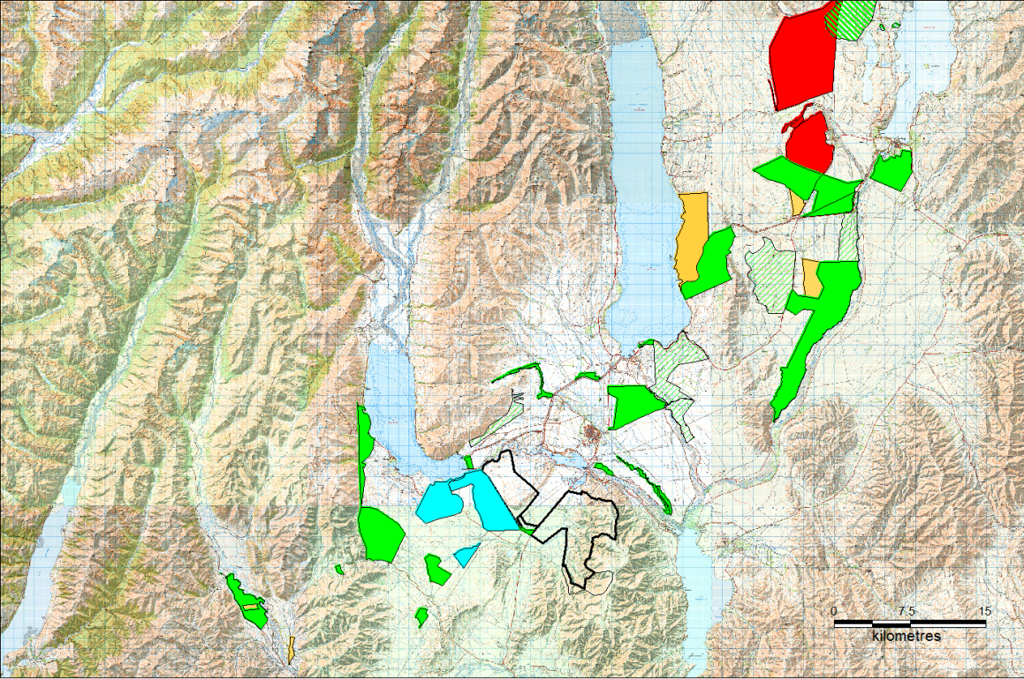
Figure 22. Mackenzie basin floor tussock grassland conservation areas, 2016.
Crown conservation area (green fill)
Conservation covenants (tan)
Identified with botanical values in current tenure reviews (Green hatch)
QEII covenants (blue fill)
Private land that will not be developed (red fill).

- The fescue tussock grasslands on deeper moraine soils are also widely protected in Mackenzie Basin conservation areas on the basin floor. Considering only crown conservation areas these consist of:
  - 4,463 ha of short tussock grassland in Irishman Creek plus 2,366 ha in grazing covenants.
  - The Maryburn conservation area consists of 4,157 ha plus 584 ha in a grazing covenant.
  - The Ben Ohau Pukaki Block consists of 1, 425 ha.
  - The Tekapo Scientific Reserve consists of1,018 ha.
  - Grasslands adjacent to, or south of Lake Ohau (excluding QEII covenants), total 2,854 ha.
  - Grasslands in the Ahuriri comprise 755 ha in crown conservation areas and 163 ha in grazing covenants.

Long Term exclusion from Grazing
Greys Hills Exclosure

- This exclosure plot was installed by the Department of Agriculture about 1910 – 1915 on Greys Hill Station, in one of the driest parts of the Mackenzie basin.
- The exclosure was fenced to exclude rabbits (Figure 23) so the vegetation has remained ungrazed for nearly 100 years.
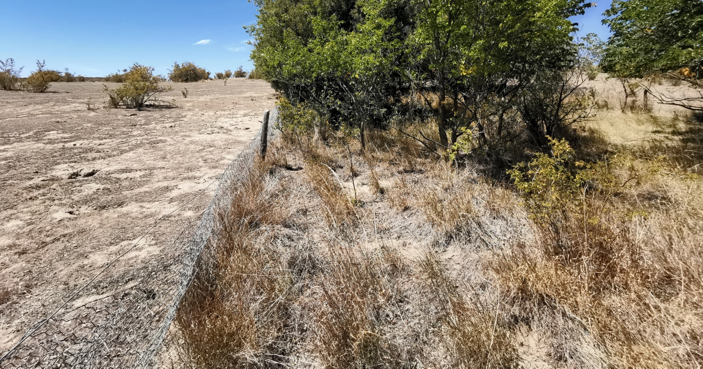
Figure 23. Gray’s Hill exclosure plot and surrounding vegetation.
- The vegetation inside and adjacent to the exclosure plot was surveyed in February 2012 with 23 1m2 quadrats outside the exclosure and 11 quadrats inside the exclosure, recording species occurrence and ground cover in open areas.
- There were no indigenous vascular species inside or adjacent to the exclosure and the only indigenous species present were two lichen outside the exclosure (Table 8). Vegetation ground cover inside the exclosure was almost entirely tall growing introduced grasses and the king devil hawkweed and outside mouse-ear hawkweed and introduced grasses or herbs.
- I conclude that competition from exotic species has eliminated the original indigenous species present. Without grazing this is due to taller growing species and accumulation of litter and with grazing this is due to the grazing adapted mat-forming Hieracium pilosella.
Ground Cover | Origin | Species | Grazed | Non-Grazed
Bare soil |  |  | 37.5 | 3.5
Litter |  |  | 11.1 | 36.2
Mouse-ear hawkweed | Introduced | Hieracium pilosella | 33.8
King devil hawkweed | Introduced | H. praelatum |  | 14.3
Cheat grass | Introduced | Bromus tectorum | 5.7
Soft brome garss | Introduced | Bro hordeaceus | 5.2
Viper's bugloss | Introduced | Echium vulgare | 1.5
Red fescue | Introduced | Festuca rubra | 3.5
Kentucky bluegrass | Introduced | Poa pratensis | 2.1 | 17.6
Sweet Briar | Introduced | Rosa rubiginosa | 0.2 | 0.4
Hare's foot trefoil | Introduced | Trifolium arvense | 0.0
Silver hairgrass | Introduced | Aira caryophyllea | 0.0
Lichen | Indigenous | Xanthoparmelia reptans | 0.0
Spring speedwell | Introduced | Veronica verna | 0.0
Tall oat grass | Introduced | Arrhenatherum elatius |  | 28.0
Lichen | Indigenous | Chondropsis viridis | 0.03
Lichen | Indigenous | Xanthoparmelia reptans | 0.01
 |  | Total | 100.8 | 100
Table 8. Effect of long-term protection from grazing on vegetation composition and percentage cover.

Glenmore Exclosure
- This site is located in a higher rainfall zone of the Mackenzie Basin in basin floor fescue tussock grassland on Glenmore Station, across Lake Tekapo from Mt Gerald Station.
- A stock holding area was rabbit fenced to exclude rabbits and retain lambs adjacent to a muster’s hut in the Forks Stream catchment on Glenmore Station. The hut was no longer needed and was removed in the 1920’s. Consequently the vegetation inside the fenced area has not been grazed for around 100 years.
- Species occurrence and percentage ground cover were recorded in six 1m2 quadrats inside the exclosure and in six quadrats in grazed grassland outside the exclosure in February 2005.
- Bare ground comprised 26% of the ground cover in grazed and ungrazed grasslands and introduced species comprised 66% and 74% of the ground cover (Table 9).
Ground Cover | Origin | Class | Grazed | Non-Grazed
Bare |  |  | 26.6 | 25.8
Browntop | Introduced | Grass | 8.5 | 18.0
Hieracium pilosella | Introduced | Herb | 56.3
Hieracium praealtum | Introduced | Herb | 1.3 | 55.8
Sheep's Sorrel | Introduced | Herb | 0.17
 |  | Total | 66.3 | 73.8
Fescue tussock | Indigenous | Tussock | 0.25
Danthonia | Indigenous | Grass | 7.0 | 0.17
Other | Indigenous | Herb | 0.15 | 0.1
Pimelea oreophilla | Indigenous | Shrub |  | 0.3
 |  | Total | 7.4 | 0.6
Total |  |  | 100.4 | 100.2
Table 9. Effect of long term protection from grazing on ground cover (%).

- Grazed grassland had higher indigenous biodiversity (Table 10). This is because grazing decreased competition from introduced tall growing species for light and nutrients allowing for greater persistence of low growing indigenous species.
 |  | Origin | Class | Grazed | Non-Grazed
 |  | Indigenous | Grass | 4. | 2
 |  |  | Herb | 13 | 4
 |  |  | Lichen | 1 | 1
 |  |  | Moss | 1
 |  |  | Shrub |  | 1
 |  |  | Total | 19 | 8
 |  | Introduced | Grass | 1 | 1
 |  |  | Herb | 4 | 2
 |  |  | Lichen
 |  |  | Moss
 |  |  | Shrub
 |  |  | Total | 5 | 3
 |  | Grand Total |  | 24 | 11
Table 10. Effect of long term protection from grazing on plant biodiversity.

- Protection from grazing in either the semi-arid or humid environments in the Mackenzie basin enhances competition from introduced species, particularly grasses and tall growing Hieracium species. Grazing, by reducing competition inform tall vegetation in wetter environments, allows the persistence of greater indigenous biodiversity of species resistant to grazing.
- This is not adequately evaluated in Mr Harding’s evidence. His evidence includes little in the way of science supporting his assertions for biodiversity loss, and should therefore not be considered a helpful source for determining the ecological impacts of particular activities.
Effect of Wilding Pines on biodiversity
The Wolds
- Wilding pine invasion occurred in a holding paddock fenced off 30 years ago (Figure 24, left of road) but not in an unfenced grazed face (right of road).
Figure 24. Wilding pine establishment in non-grazed and grazed grassland.
- Five 1m² quadrats were placed every 5 m along transects run mid-slope under non-grazed fully closed and open canopies and in the adjacent grazed grassland. Species occurrence and percentage cover were recorded.
- Full canopy closure and litter fall under wilding pines eliminated almost all ground species in contrast to grazed grassland (Figure 25) and non-grazed open canopy (Table 11).
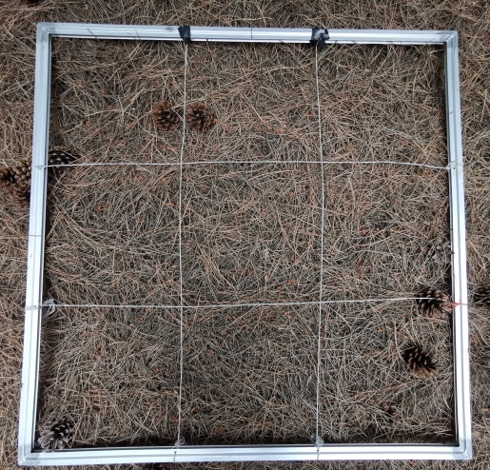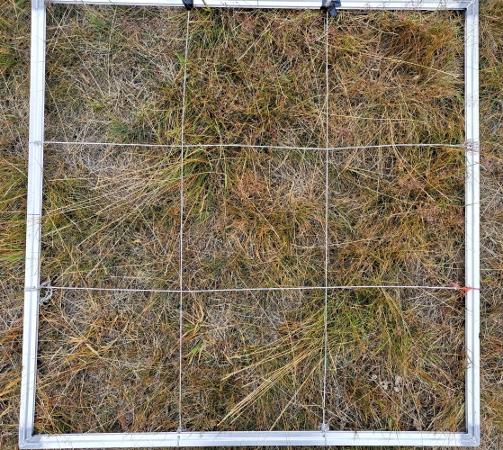
Figure 25. Ground cover under non-grazed closed canopy (left) and grazed grassland (right).

Ground Cover | Origin | Species | Grazed | Non-Grazed
 |  |  | Open | Open | Closed
Bare soil |  |  |  | 34 | 1
Litter |  |  | 6 | 15 | 96
Mouse-ear hawkweed | Introduced herb | Hieracium pilosella | 11 | 40 | 3
Browntop | Introduced grass | Agrostis capillaris | 32 | 6
Red fescue | Introduced grass | Festuca rubra | 46 | 1.4
Sweet vernal | Introduced grass | Bro hordeaceus | 6 | 1.6
Silver hairgrass | Introduced grass | Aira caryophyllea |  | 0.2
Kentucky bluegrass | Introduced grass | Poa pratensis |  | 0.2
Yarrow | Introduced herb | Achillea millefolium | 0.04
Sheep's sorrel | Introduced herb | Rumex acetosella | 0.02
Moss | Indigenous moss |  |  | 2.1
Blue tussock | Indigenous tussock | Poa colensoi |  | 1.4
NZ Bluebell | Indigenous herb | Wahlenbergia albomarginata | 0.02
Matagouri | Indigenous shrub | Discaria toumatou |  | 1.1
 |  | Total | 100 | 100 | 100
Table 11. Effect of grazing and wilding canopy closure on species ground cover percentage.
Pukaki Flat
- Wilding pine invasion increased between 2015 and 2012 at the Ben Ohau Pukaki Flat research site (Figures 24, 25).

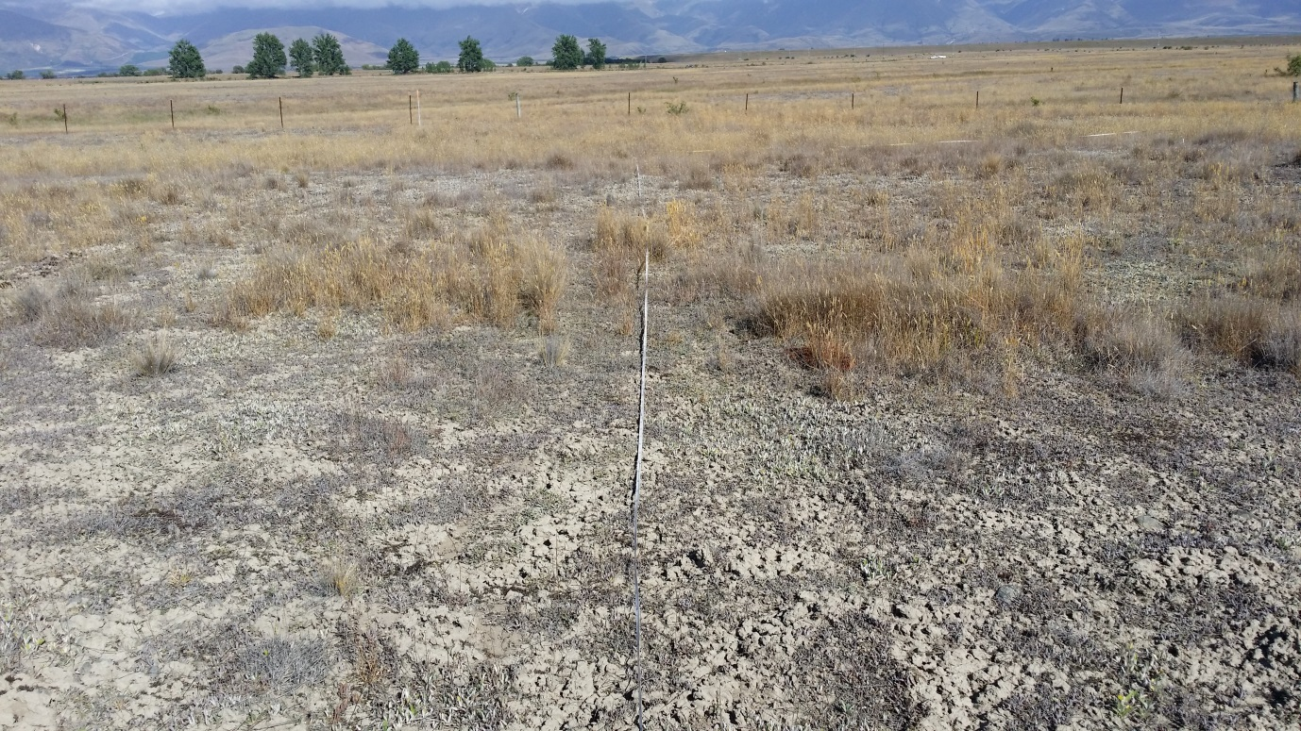

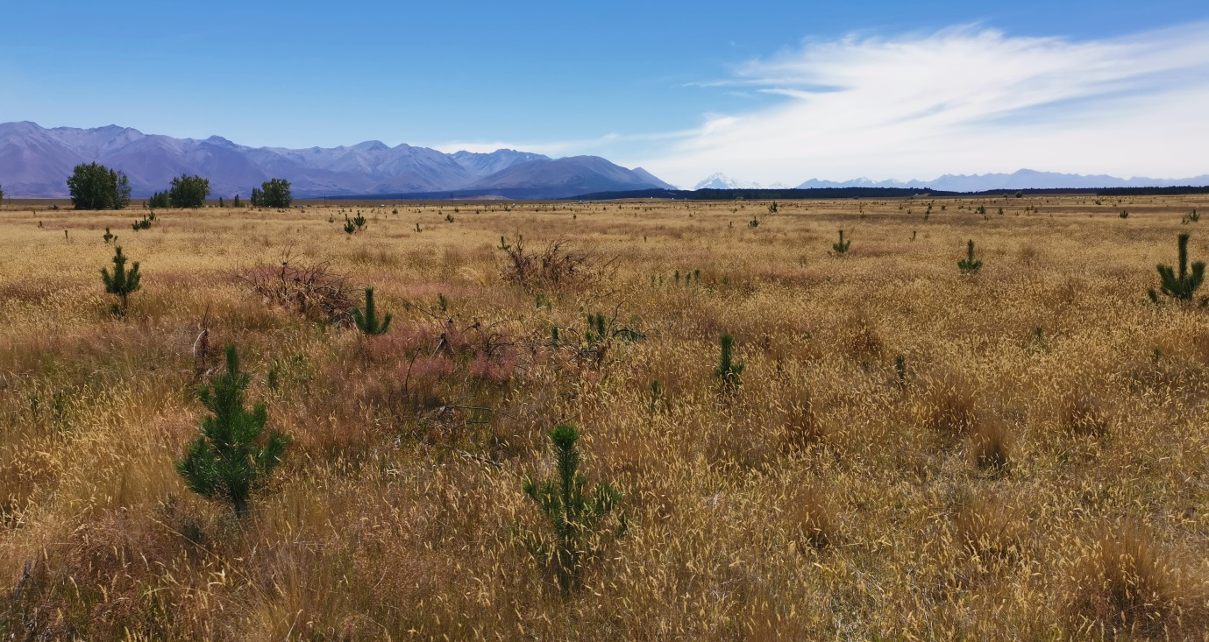
Figure 24. Wilding pines on Pukaki Flat site in 2015 (upper) and 2021 (lower). Note the dead felled pines from previous control in the 2021 image.

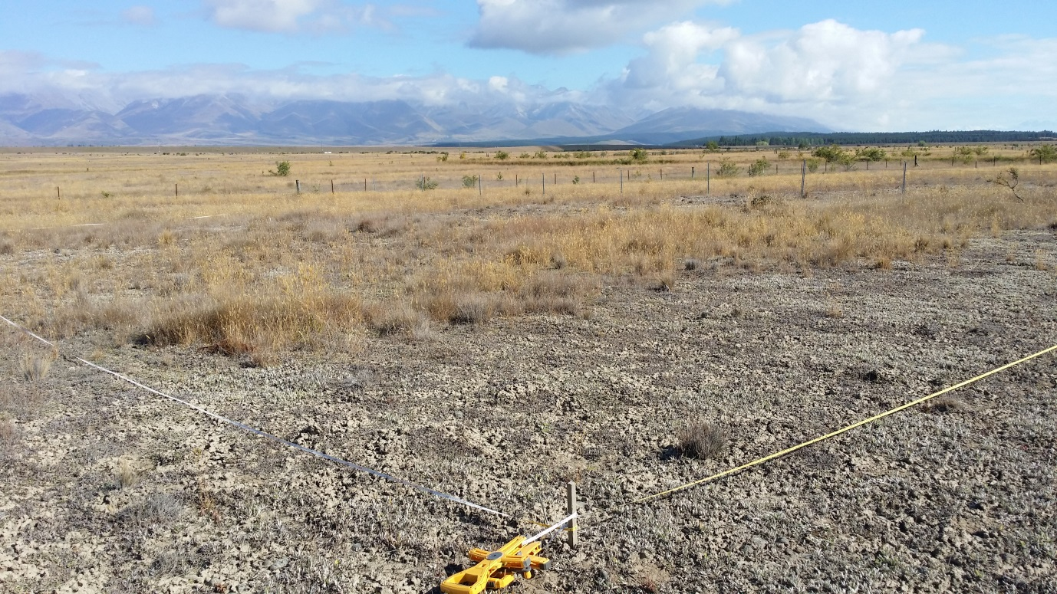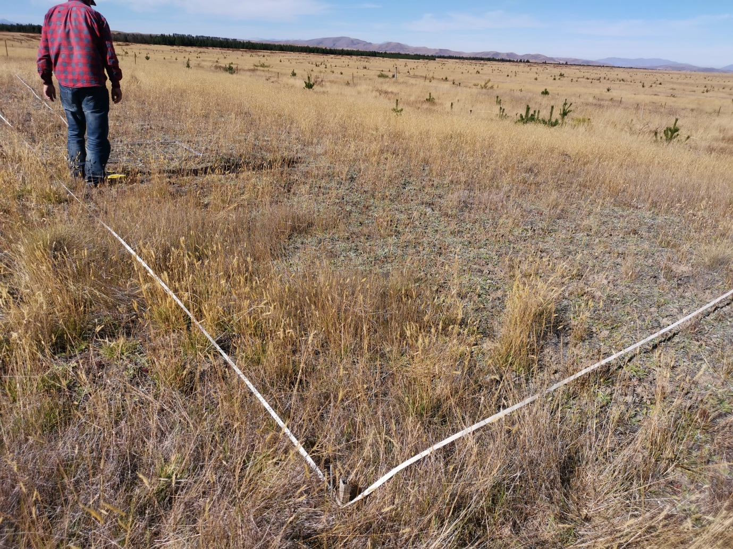Figure 25. Wilding pines on Pukaki Flat plots in 2015 (upper) and 2012 (lower).

- All visible wilding pine were counted in the entire 65 x 65 m exclosure plots and in in a similar area on the previously grazed treatment, discontinued with reversion to Department of Conservation management (Table 8).

Grazing | Area (m²⁾ | Wildings/ha
+ Rabbit + Sheep* | 4,392 | 296
+ Rabbit -Sheep | 4,002 | 205
- Rabbit -Sheep | 4,002 | 290
Table 8. Density of wilding pines and research grazing treatments.
* Note this treatment ceased after DOC control.

- This high density of wilding occurred after two previous control cuts. This shows the requirement for continual ongoing wilding management if protection of indigenous biodiversity is required. This management is costly. Currently $30 million has been allocated for the current round of wilding pine control in the Mackenzie basin. Ongoing Future expenditure will be required.
- This high density of wilding occurred after two previous control cuts. This shows the requirement for continual ongoing wilding management if protection of indigenous biodiversity is required. This management is costly. Currently $30 million has been allocated for the current round of wilding pine control in the Mackenzie basin. Ongoing Future expenditure will be required.
Mt Aurum/ Ben Lomond
- The effect of wilding pines on biodiversity in the Mackenzie occurs throughout the high country. I include a study from near Queenstown with different control methods, which shows long term effect on biodiversity from the various control methods, and particularly the beneficial effect of grazing.
- Conifer increase and spread in and around the Mt Aurum Queenstown (Figure 26), was recognized as a problem, and management strategies were recommended to contain the conifers to designated areas . Containment of wilding pines was formally adopted in the Mt Aurum Recreation Reserve conservation management plan.
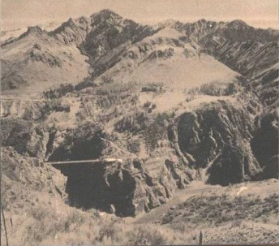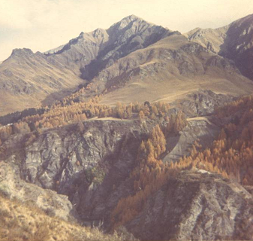
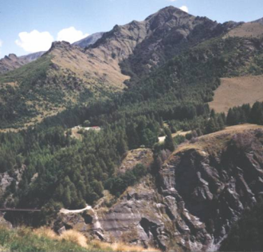
a) 1970’s - early 1980’s b) 1983
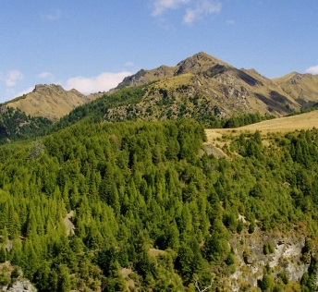
c) 2003 d) 2006
Figure 26. Progressive wilding expansion, Mt Aurum 1970’s -2006.
- In April 2005 an initial site inspection was made of vegetation and wildling spread in the Mt Aurum Recreational Reserve and Ben Lomond Station in the upper Shotover catchment.
- In March 2006, six 10 x 10 m grassland plots and one reconnaissance 4 x 4 m plot, one 20 x 20 m shrubland plot and three 10 x 10 m forest plots were assessed in Ben Lomond and Mt Aurum Recreational Reserve. Representative sites were chosen for areas under different managements, or aspects, and plot positions were then located by random number. Plot locations were measured by a Trimble Global Positioning System (GPS) to ± 4.5 - 6 m accuracy for subsequent Geographic Information System (GIS) mapping.
- Site information is summarised in Table 12. “Hand” is used to indicate hand cutting and spraying of wilding pines; “Spray” to indicate aerial application of herbicide, (Tordon Brushkiller applied at label rates) and “Grazed” to indicate pastoral grazing by merino sheep 1 Stock Unit / ha at Ben Lomond; 0.25 SU/ ha at Low’s Terrace). Low intensity grazing by feral animals, principally goats and hares, may also have occurred.
Area |  |  |  |  | Mt Aurum |  |  |  |  | Ben Lomond
Vegetation |  |  | Forest |  |  |  | Grassland |  |  |  | Grassland
 |  | Douglas Fir |  | Larch | Unimproved |  |  |  |  | Unimproved |  | Dvpt.
Location |  | Londonderry Tce |  | Skippers | Pleasant Stream |  |  | Cook's Tce |  | Low's Tce |  | Ben L.
Plot |  | L1 | L2 | S1 | P1 | P2 | P3 | C1 | C2 | BL1 | BL2 | BL3
Aspect |  | Shady | Sunny | Shady | Shady | Sunny | Sunny | Shady | Sunny | Shady | Sunny | Shady
Altitude m |  | 590 | 600 | 615 | 530 | 640 | 655 | 600 | 645 | 625 | 560 | 650
Management |  | Nil | Nil | Nil | Hand | Hand | Hand | Spray | Spray | Grazed | Grazed | Grazed
Area m² |  | 100 | 100 | 100 | 100 | 100 | 100 | 400 | 13 | 100 | 100 | 100
Table 12. Site details, management and plot characteristics.

- Plant biodiversity in the different communities is shown in Table 13.
Area |  |  |  | Mt | Aurum |  |  |  |  | Ben Lomond
Vegetation |  |  | Forest |  |  |  | Grassland |  |  | Grassland
Wilding Mgmt. |  | Nil |  |  | Hand Cut |  |  | Sprayed |  | Grazed
Plot |  | L1 | L2 | S1 | P1 | P2 | P3 | C1 | C2† | BL1 | BL2 | BL3
Origin | Class
Exotic | Grass |  |  | 2 | 3 | 4 | 4 | 2 | 2 | 3 | 4 | 4
 | Herb | 1 |  | 3 | 4 | 2 | 2 | 2 | 5 | 5 | 4 | 7
 | Shrub |  |  | 1 |  | 3 | 2 |  |  | 1 | 1 | 2
 | Tree | 1 | 1 | 1 | 2 | 2 | 2 | 1 |  |  | 2 | 1
Exotic Total |  | 2 | 1 | 7 | 9 | 11 | 10 | 5 | 7 | 9 | 11 | 14
Native | Fern | 1 |  | 3 | 2 | 1 | 1 | 1 |  | 1 |  | 1
 | Grass |  |  |  | 1 |  | 1 | 1 |  | 1 | 2 | 1
 | Herb |  |  |  | 12 | 3 | 2 | 3 | 3 | 6 | 5 | 9
 | Lichen |  |  |  | 3 |  | 2 |  |  | 1
 | Tussock |  |  |  | 3 | 1 |  | 2 | 2 | 3 | 2 | 1
Native Total |  | 1 | 0 | 3 | 21 | 5 | 6 | 7 | 5 | 12 | 9 | 12
Grand Total |  | 3 | 1 | 10 | 30 | 16 | 16 | 12 | 12 | 21 | 20 | 26
Table 13. Vascular plant diversity in forest and grassland communities
† Note: only a small reconnaissance plot 13% the size of normal plots.
- Conifer invasion significantly reduced plant diversity. The closed canopy Douglas fir communities (L1, L2) had extremely low species diversity with only two other species present. Diversity rose in the deciduous Larch community S1, but was still considerably less than in the directly comparable shady aspect grasslands P1 (10 vs. 30 total species, 3 vs. 21 native species).
- Aspect affected grassland diversity. Diversity was highest on shady aspects, 30 vs. 16 total species at Pleasant Stream and 26 vs. 21 species on Ben Lomond. It is probable this is mainly due to environmental conditions and plant competition, rather than long-term lag effects from previous grazing under Mt Aurum station.
- Extensive grazing did not significantly reduce diversity. Comparing the adjoining ungrazed Pleasant stream and grazed Ben Lomond grasslands (P1-3 vs. BL1-2), average diversity was species 23 against 20.5. Ungrazed shady aspect grasslands held more species than grazed grassland, the reverse occurred on sunny aspects.
- Conifer management may also have affected diversity. It is striking that the aerially sprayed shady grassland with Hebe odora shrubs (C1) had only 12 species in total, a level of diversity similar to that under Larch, compared with 30 on comparable shady aspect grasslands at Pleasant Stream, despite having four times the area. It is possible herbicide drift may have affected grassland species. Similarly, the diversity in the sprayed sunny aspect grasslands (C2) was lower than both the Pleasant Stream and Ben Lomond sunny grasslands, though this is inconclusive due to the smaller size of the C2 plot.
- The diversity in the most intensively developed pastoral grassland, BL3, was very similar to that in the comparable Pleasant Stream shady aspect grassland P1 (26 vs. 30 total species), though intensification reduced the proportion of native species (12 vs. 26 species). This site had been spring burnt in 1991 and 2003.
- It is evident that conifer establishment has fundamentally altered vegetation structure and significantly reduced plant diversity at Mt Aurum. Douglas fir dominance resulted in an almost complete elimination of all other species and Larch resulted in a 3-fold reduction in total species biodiversity and a 7-fold reduction in native species. As vegetation provides the primary habit for fauna, total system biodiversity would also be expected to decline. Although it is well established that conifer invasion is a major threat to indigenous biodiversity in South Island tussock Grasslands, the long-term impacts in terms of future ecological successions under conifers are not known.

CONCLUSION
- Scientific assessments indicate a widespread, progressive, general deterioration in tussock grassland communities, as a direct consequence of plant completion by exotic species.
- This is fundamental to biodiversity management and is not adequately presented in the scientific evidence the Mackenzie District Council used to base its recommendations on Plan Change 18.
- The proposed definition of indigenous vegetation is flawed and requires revision.
- The complete suite of vegetation communities, faunal habitats and indigenous species are already adequately protected in conservation areas in the Mackenzie basin and in other conservation areas in other similar districts. This will achieve the goal of no net loss of biodiversity in the Mackenzie District.
- I conclude that the proposed indigenous vegetation clearance rules require substantial revision based on a correct definition of indigenous biodiversity and practicable non-specialist application by the community.

M Harding Mackenzie District Plan Proposed Plan Change 18 – Indigenous biodiversity, Section 42a Hearings Report – Ecology, paragraph 29.
Harding evidence, paragraph 30.
Harding evidence, paragraph 38.
Harding evidence, paragraph 41.
Espie et al. 1984. Mackenzie Ecological Region Protected Natural Areas Survey, Department of Lands and Survey , Wellington.
Harding evidence, paragraph 44.
Harding evidence, paragraph 45.
Harding evidence, paragraph 47.
Harding evidence, paragraph 48.
Espie et al. 1984. Loc.cit.
Harding evidence, paragraph 53.
Harding evidence, paragraph 58.
Harding evidence, paragraph 59.
Harding evidence, paragraph 63.
Harding evidence, paragraph 62.
Harding evidence, paragraph 64.
Harding evidence, paragraph 68.
Harding evidence, paragraph 67.
Harding evidence, paragraph 73.
Harding evidence, paragraph 87d.
Harding evidence, paragraph 87e.
Harding evidence, paragraph 87f.
Harding evidence, paragraph 91.
Harding evidence, paragraph 94.
Harding evidence, paragraph 95.
Harding evidence, paragraph 101.
Harding evidence, paragraph 103.
Harding evidence, paragraph 104.
Harding evidence, paragraph 115.
Harding evidence, paragraphs 116, 125.
Harding evidence, paragraph 117.
Cox, S.C., Barrell, D.J.A. 2007. Geology of the Aoraki Area, Institute of Geological and Nuclear Sciences 1:250,000 Geological Map 15, GNS Science, Lower Hutt, Wellington; Lynn, I. 1993. Land types of the Canterbury Region, in The Canterbury Regional Landscape Study, Boffa Miskell and Lucas Associates.
Webb, T.H. 1992. Soils of the upper Waitaki basin. DSIR Land Resources Scientific Report No 3.
Connor, H.E. 1964. Tussock grassland communities in the Mackenzie country, South Canterbury, New Zealand. New Zealand Journal of Botany 2: 325-351.
Espie, P.R. et al, 1984. Mackenzie Ecological Region, NZ Protected Natural Areas Programme, Department of Lands & Survey, Wellington.
Espie, P.R. 2008. Simons Pass Station Tenure Review Botanical Assessment. AgScience Contract Report.
Espie, P.R et al. 1984, loc. cit.
O’Connor 1976, loc. cit.
Espie P.R. 2001. Hieracium in New Zealand, ecology and management., AgResearch, Invermay.
Mackintosh , P., Allen, R.B. 1993. Soil pH declines and organic carbon increases under Hawkweed (Hieracium pilosella). NZ Journal of Ecological Research 17: 59-80.
Boswell, C.C & Espie, P.R. 1998. Uptake of moisture and nutrients by Hieracium pilosella and effects on soils in a dry sub humid grassland. NZ Journal of Agricultural Research 41: 251-261.
Painter, D.J. Brief of Evidence. Resource consent applications for water use in the upper Waitaki, 2009.; Basher, L.R. and Webb, T.H. 1997. Wind erosion rates on terraces in the Mackenzie Basin. Journal of the Royal Society of New Zealand 27: 499-512.
Painter, D.J. Brief of Evidence. Resource consent applications for water use in the upper Waitaki, 2009.; Basher, L.R. and Webb, T.H. 1997. Wind erosion rates on terraces in the Mackenzie Basin. Journal of the Royal Society of New Zealand 27: 499-512.
Webb, T.H. 2016. Brief of evidence, Carr & Brookside Trust and Gallaway Cook Allan, High Court of New Zealand, Auckland Registry, 16th February 2016.
Espie, P.R. 2016. The Wolds Production Trial, unpublished data.
Ledgard, N. 1990. The spread of introduced conifers at Mt Aurum station: background, present situation and management options. DOC Contract Report: 19 pp.
Department of Conservation, 1991. Mt Aurum Recreation Reserve Conservation Management Plan.
Harding, M. 2001 South Island Wilding Conifer Strategy, Department of Conservation, Christchurch.
Queenstown Lakes District Council 2004. Ben Lomond and Queenstown Hill Management Plan

