In the matter of the Resource Management Act 1991

And

In the matter of the proposed Plan Change 18 (Indigenous Biodiversity) notified by the Mackenzie District Council

STATEMENT OF evidence of Michael Burtscher
for mt gerald station Limited
12 February 2021

Duncan Cotterill
Solicitor acting: Katherine Forward
PO Box 5, Christchurch

Phone +64 3 379 2430
Fax +64 3 379 7097
katherine.forward@duncancotterill.com

introduction

- My name is Michael Burtscher. I am a farmer and businessman, and I live and work at both Mt Gerald Station and Christchurch. This evidence is given on behalf of Mt Gerald Station Limited (Mt Gerald).
- The development of planning regimes in the Mackenzie is very important to me. I have been involved with various processes, particularly Plan Change 13 (PC13) and various resource consent applications. Like those other processes, this proposed Plan Change 18 (Indigenous Biodiversity) (PC18) will also have significant impacts on how we live and work on Mt Gerald.

The Farm

- Richmond Station as a farming activity was founded in 1858. Separation of Richmond Station into Run 77 (Richmond) and Run 77A (Mt Gerald) occurred in 1910.
- The 1948 Land Act provided for pastoral leases in perpetuity with exclusive right of pastoral activities, possession, and quiet enjoyment. The Act enabled security of tenure which was the platform and enabler for better ongoing land management. Both Richmond and Mt Gerald were formerly farmed under pastoral leases Run 289 (formerly 77) and Run77A respectively.
- In 1952 the lakeside was surveyed, and various sections along the lakeshore were surrendered from the lease.
- In 1973 the Richmond lease was varied and part (circa 2242 hectares) of the adjacent Richmond Range was surrendered from the lease for tourism purposes.
- The Crown Pastoral Land Act came into effect 1998.
- In 1990 significant parcels (totalling approximately some 14,000 hectares) were surrendered from Mt Gerald Station as part of the Run Plan in which the Lessee retired Class 6, 7, & 8 land in exchange for crown expenditure for development and intensification activities such as fencing, shelter belts, pasture improvements, and tracking.
- In 2007 Richmond completed the tenure review process retiring 3630 hectares to conservation. Mt Gerald subsequently acquired the bulk of the Richmond Run in freehold title, ending 97 years of separation of the two. The property continues to be run as one farming unit.
- Mt Gerald has also completed tenure review and land identified for farming and intensification has been transferred to freehold fee simple with the balance 1786 hectares retired from grazing to public conservation estate. At the time, conservation, cultural, recreational, historic, and economic values amongst others were again considered (as with all tenure reviews) at length resulting in outcomes satisfactory to the Lessee, Crown, NGOs, Iwi, and Public.
- PC13 was also an extensive publicly notified and detailed process. PC13 s293 provisions changed the goal posts and added a further layer of restrictions across land which the Crown and DoC as advisor to the Crown, through tenure review, has deemed appropriate for intensified use. If PC18 proceeds as currently proposed I am concerned that it will make farming unviable – particularly in light of the broad and all-encompassing definitions of what constitutes ‘indigenous vegetation’ and ‘vegetation clearance’ and the uncertainty of how ‘improved pasture’ will be interpreted.
- Further, I consider it is entirely inappropriate that the Council Officer’s report seeks to amend the ‘vegetation clearance’ definition to also include (together with irrigation as notified): artificial drainage, oversowing, topdressing and overplanting. On the back of PC13 it is critical that maintenance agricultural conversion and pastoral intensification activities are provided for and that the consenting process is not unduly burdensome for landowners.
- The lands farmed as Mt Gerald have for over 150 years been subject to change, including via vegetation clearance activities. That historic practice has led to areas on the property becoming more suitable for the farming activities conducted today, and more latterly (over the past 70 years) as a result of the Land Act 1948, Crown Pastoral Land Act 1998, the Run Plan, Tenure Review, numerous resource consents obtained and PC13, a more intensified farming activity.

Indigenous Biodiversity

- I accept that significant indigenous biodiversity is important and support its protection where appropriate. However, to me it defies logic that these protections will cover areas that have historically been used for farming, have been identified as appropriate for intensification under the tenure process and have been subject to extensive modification over many years, including:
  - Burning of vegetation;
  - Topdressing and over-sowing;
  - Application of seed, fertiliser;
  - Irrigation water;
  - Pasture and paddock development; and
  - Extensive damage by pests (rabbits, hyracium, and more recently wilding pines) as well as work to eradicate those pests.
- The definitions that control indigenous vegetation (as proposed by the Council) are flawed. They don’t take into account that often the actions of farmers have enabled the continuation of some indigenous species, and that activities like topdressing and over-sowing has allowed exotic species to exist in tandem, and has protected indigenous vegetation from pest species. These matters are covered in detail in the evidence of Mr Peter Espie.
- It is unrealistic on vast High Country Stations in the Mackenzie Basin to limit areas of ‘improved pasture’ and therefore permitted activity status for indigenous vegetation clearance to “an area where, as at May 2020, indigenous vegetation has been fully removed” as proposed in the Council Officer’s report. On Mt Gerald, there are many examples of areas which are improved pasture (having been subject to various pastoral intensification and agricultural conversion processes over the years) but where small numbers of native species are still present. This is due to farm management practices and is entirely dependent on cycles of pasture renewal and pest control etc.

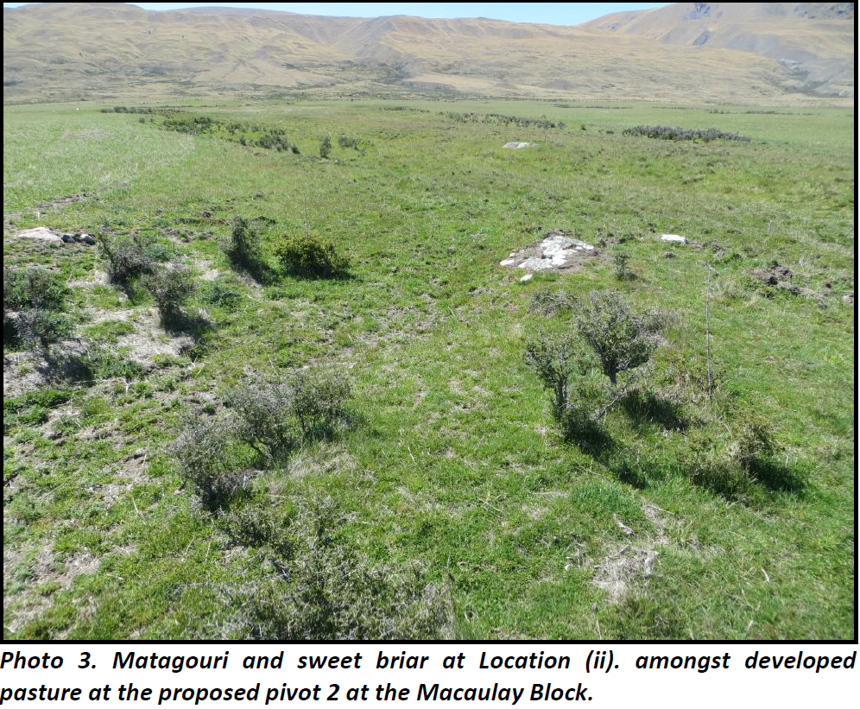
- As I read PC18, there are no permitted provisions for any development related indigenous vegetation clearance. This is critical for efficient land management and productive use of the land, particularly on areas where farming has historically occurred, but indigenous vegetation is still partially present. We can’t be required to seek resource consent every time we need to make farming decisions – this is inefficient and in direct conflict with the RMA concept of sustainable management

Economic impacts

- I consider that the section 32 report has not identified or analysed the economic realities of current and future rural land use activities in the Mackenzie District, or the effect of the proposed plan change on ongoing sustainable rural land use. I understand that the RMA requires that these matters (social and economic considerations) must also be considered. The requirements of PC18 also need to be considered in the context of all the other requirements imposed on rural land users, such as the landscape implications of PC13, and recent changes to the Freshwater regime.
- Mt Gerald allocates significant funds to pest control (wilding pine, broom, thistle, rabbit, wallaby, hare etc), some of which would potentially need to be redirected to compliance for maintenance farming practices if there is no permitted activity pathway for these activities to occur. I am particularly concerned about the expense associated with preparing detailed farm biodiversity plans if these are required. The math is simple, and the more spent on compliance to simply maintain existing operations, will result in less expenditure on for example pest control. In the event, that PC18 becomes operative in its current form, Mt Gerald may not be in a position to invest the same funds towards maintaining indigenous biodiversity as revenue could be significantly affected. The result is that remnant indigenous biodiversity on private land may decline further without active landowner intervention.
- The NPS Biodiversity Strategy acknowledges a collaborative approach is needed with landowners to preserve areas of significant vegetation. Without providing landowners with a clear path to generate income from the land, NZ’s remaining biodiversity will suffer. PC18 seeks to provide a blanket approach to vegetation clearance of indigenous vegetation regardless of whether this has been identified as significant or not. This approach will severely cripple the unique Mackenzie Basin rural industry and reliant economy.
- Importantly, the changes proposed to the definition of ‘vegetation clearance’ as detailed in the Council Officer’s report have not been considered in line with s32 of the RMA. The impact of extending the definition to include other pastoral intensification and agricultural conversion activities fails to have regard to the economic and social effects that will be borne by the landowner.

Tenure review process

- It has been a common theme through all the planning processes in the Mackenzie District that the tenure review seems to be ignored. Mt Gerald/Richmond was subject to rigorous assessment and areas of significant value (including biodiversity/ecology) were identified and either returned to the Crown or protected in other ways. PC18 must be viewed in this context and the ongoing limits placed on land use and the flow on implications to the landowner, understood and acknowledged.

Wetlands, Converted and Partially Converted Pasture mapping

- The wetland areas as set out in the proposed ECan GIS wetland layer on Canterbury Maps (which appear to be aerial in nature) are both incorrect and misleading and do not represent the ground truth; as supported and set out in the evidence of Mr Peter Espie. The correct extent of these areas is directly relevant to PC18 as resource consent is required where vegetation clearance is proposed within 50m of any wetland. As Mr Espie’s evidence shows, wetland areas identified on Mt Gerald include large buffer zones that would result in additional setbacks over and above the 50m setback required under the vegetation clearance provisions.
- Further, and as a further example, when the Court was assessing Farm Base Areas in PC13, there was much discussion as to the location of a small wetland at the North West end of the Mt Gerald Farm Base Area. After site visit(s) the small area was mapped. At no time was there any mention of further wetland area anywhere in the vicinity. That small area now appears to be depicted as a significantly larger area on the Canterbury Maps database. This particular inconsistency again highlights the issues with the current mapping.
- Again, the areas of proposed Converted and Partially Converted pastures appear to be incorrect, probably due of the aerial nature of the mapping and resultant lack of detail and ground truth. It is understood that Council anticipate a future plan change to incorporate the proposed maps in Harding’s evidence. This is critical to ensure that all areas that identify as converted/ developed land are included within this mapping exercise. Currently, there are several areas on Mt Gerald that exhibit identical vegetation cover to those included as partially converted and/ or converted that are not included. As has been the case with Farm Base Areas under PC13, these areas will prove pivotal in authorising existing and future intensification.
- Topdressing and pasture development as set out in the Mt Gerald Certificate of Compliance application (copy attached at Appendix A) clearly shows the areas of existing development at that date – pre notification of Plan Change 17. Those areas are also supported by expert vegetation assessment(s) prepared by Mark Sanders from Ryder Consulting (copies of the irrigation development (Appendix B) and the hay paddock assessments (Appendix C) are attached.

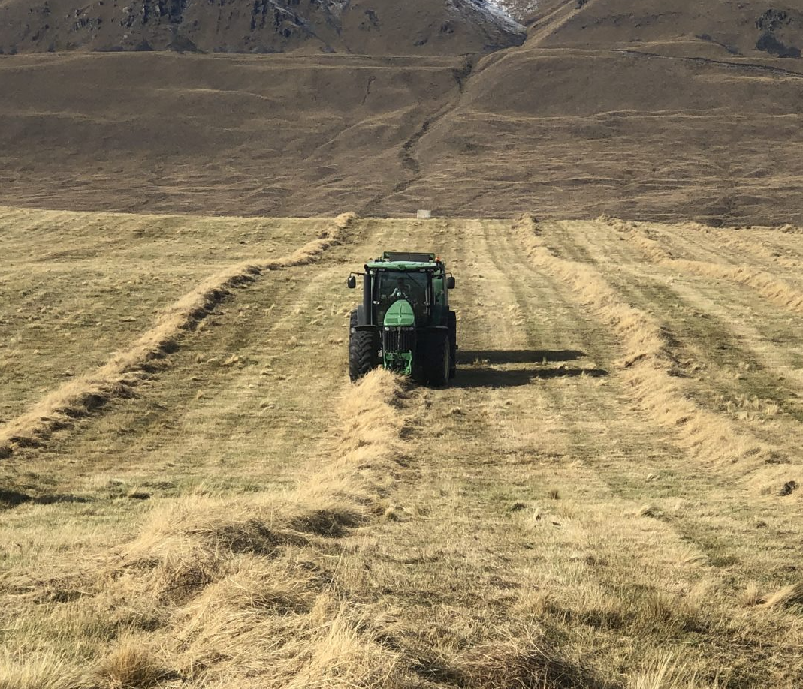 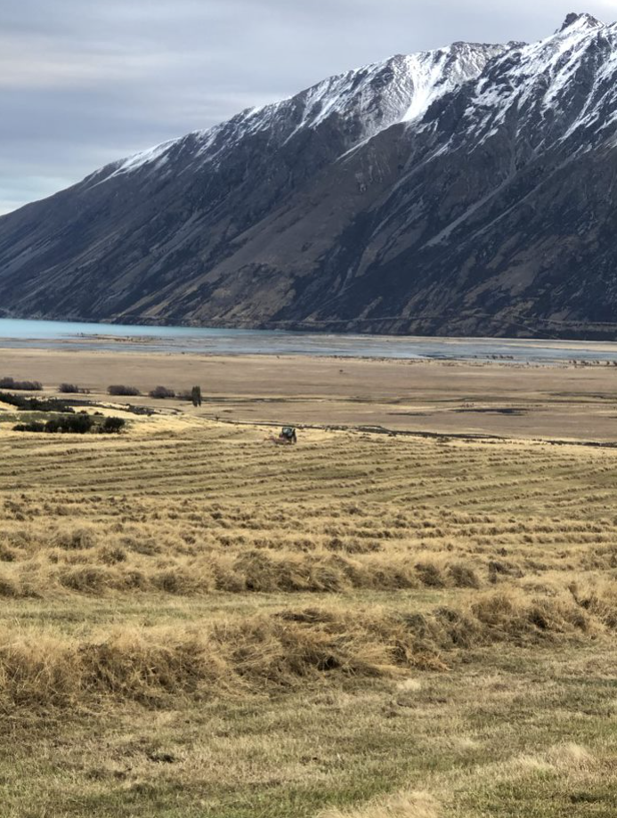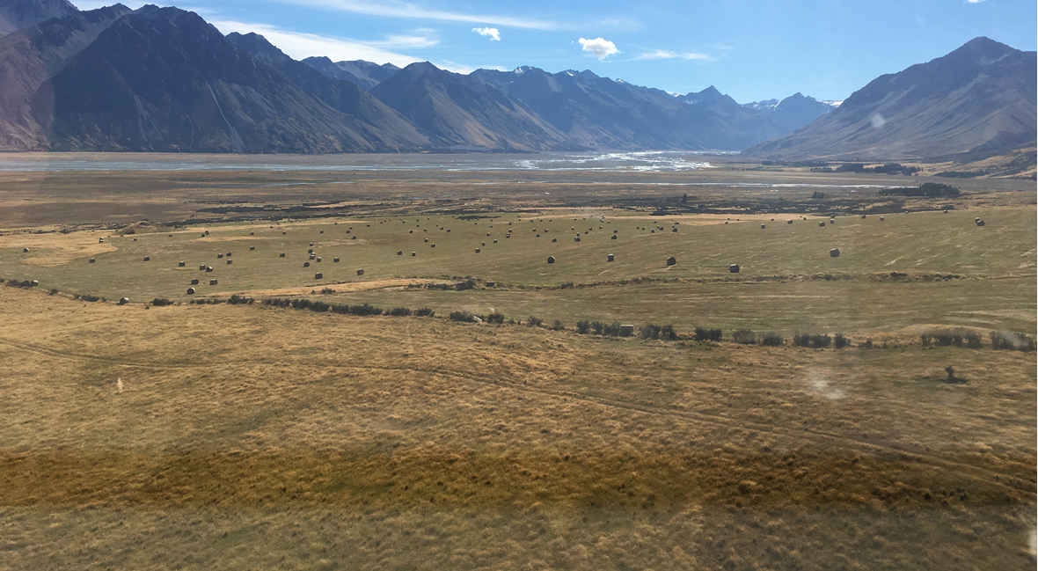Photographs depict haymaking on converted farmland at Mt Gerald Station. This is the same area as considered in the Appendix C vegetation assessment.

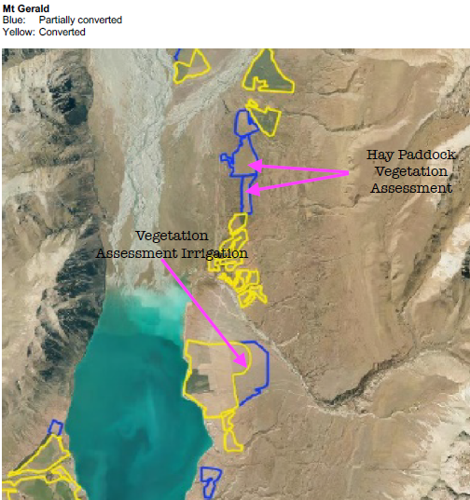
- It is understood that the proposed Harding mapped areas of converted and partially converted land were identified through aerial imagery as at May 2020 and based on Council internal records of resource consents or like authorisations granted. Given the nature and distortion of aerial imagery it is likely that there are vast areas across the Mackenzie Basin that ought to have been included as converted land which has not – particularly where historical practices have been undertaken as permitted activity or reliant on existing use rights.

conclusion
- PC18 is in direct conflict with PC13 and it is disappointing that the Council has not delayed deciding PC18 until such time as there is clear Government direction on the NPS Indigenous Biodiversity – this is a poor and inefficient use of resources.
- The current definition(s) relating to ‘indigenous vegetation’, ‘vegetation clearance’ and ‘improved pasture’ are unworkable in the context of a working farm and there is no consideration whether the proposed changes will actually address vegetation decline. Mr Espie provides clear evidence that the environmental outcomes sought will not be achieved through the proposed provisions. Locking up the Mackenzie Basin is not the answer.
- Moreover, the use of positive farming techniques that produce better outcomes in protecting native species such as tussock, protecting retention of soil bases, the reduction of wilding pines and vermin afford no mention.
- The lack of balanced indigenous vegetation definition(s) combined with non-detailed aerial mapping, again in the context of a developed working farm environment is not only unworkable but discriminatory when measured against years of historic activities and agreement(s) with Crown and Public entities.
- Agriculture is an important contributing sector in the Mackenzie District community and economy and further restrictions will impose further unacceptable social and economic costs.
- The restrictions that are proposed are not consistent with people and a community’s economic wellbeing or the efficient use and development of natural and physical resources and there has not been sufficient Section 32 analysis to date.
- Detailed ground truth analysis should be completed, along with individual property owner consultation and agreement, in conjunction with historical agreements being adhered to, prior to the completion of PC18, at the sole cost of Council.
- Failure to complete detailed analysis could well result in significant economic damages to our property and business, considering previous funds deployed to ongoing development of the farm property and business, the potential loss of future earnings, and the potential decrease in capital value.

Michael Burtscher
12 February 2021

